Parsons, Spring 2023

International Trade Policy: Take-home Midterm レポート

Instructions: Answer ALL questions below to the best of your ability. Do NOT simply copy my notes or sentences from the text. Express the ideas in your OWN words. You must hand in this exam on July 11st, 2023. If you have any questions, please contact me by phone (X3539) or e-mail (parsons-craig-gj@ynu.ac.jp).

Part I: Partial Equilibrium Analysis of Tariffs

- Go here at MRU website.
https://practice.mru.org/interactive-practice-trade/?_ga=2.115089410.400599733.1686606308-714510291.1686606308
Do “Trade Tariffs” and “Winners and Losers from Trade” quizzes. Write your name. Print out the PDF of your results. There are TWO quizzes.

Partial Equilibrium Analysis Costs and Benefits
You must draw all graphs by hand.

- Effects of a Tariff

Draw an Import Tariff Graph assuming the world price is lower than the domestic price. Also assume the country is SMALL.

In your graph, describe the amount of imports before and after the tariff.

Describe in detail the gains and/or losses to producers，consumers, and government revenue and deadweight loss by using the appropriate polygonal areas in your graph.

- Referring to your graph in Problem 2, explain how the effects of an Import Quota (again, small country) are the same and different than an import tariff.

- Import tariff (Large country case). Re-draw the graph in Problem 2 and re-do the analysis in the case that the importing country is LARGE. *Draw your case so that the extra Terms of Trade effect (area E) is SMALLER than the DWL.

- Export subsidy (small country case). Draw a graph and explain the effect of an Export subsidy on Prices, Exports, Quantity Produced and Consumed (at home). Also, explain the effects on CS and PS. Also explain which area describes the Cost of the subsidy and the DWL caused by the subsidy. (See Notes1/KOChap8 text)

- Export Subsidy (LARGE country case). Draw a new graph and explain all effects as in the above problem 5, plus the additional Terms of Trade effect. How has the DWL changed? Will this be a net gain, or net loss for the country? (See Notes1/KOChap8 text)
- (5 pts) What is a Specific tariff and an Ad Valorem tariff. Briefly explain.

- (5 pts) What does NTB stand for? Give two examples.

- Export Tax (small country case). Draw a new graph and explain all effects as in the above problem 5. (Note, now there will be tax revenue.) Will this be a net gain, or net loss for the country? Explain.

Part II : Chapter 3 in Krugman, Obstfeld, Melitz Ricardian Comparative Advantage

- Use the information in the table below to answer the following questions.

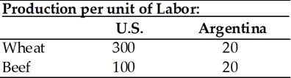

- Does either country have an absolute advantage in the production of wheat or beef? Explain.
- What is the opportunity cost of wheat in each country?
- What is the opportunity cost of beef in each country?
- Analyze comparative advantage and opportunities for trade between the U.S. and Argentina.

- Use the information in the table below to answer the following questions.

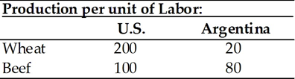

- Does either country have an absolute advantage in the production of wheat or beef? Explain.
- What is the opportunity cost of wheat in each country?
- What is the opportunity cost of beef in each country?
- Analyze comparative advantage and opportunities for trade between the U.S. and Argentina.

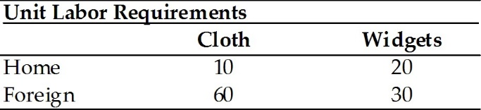

- Given the information in the table above
- neither country has a comparative advantage in cloth.
- Home has a comparative advantage in cloth.
- Foreign has a comparative advantage in cloth.
- Home has a comparative advantage in both cloth and widgets.
- neither country has a comparative advantage in widgets.

- Given the information in the table above, if wages were to double in Home, then Home should
- export cloth.
- export widgets.
- export both and import nothing.
- export and import nothing.
- export widgets and import cloth.

- Assume that labor is the only factor of production and that wages in the United States equal $20 per hour while wages in Japan are $10 per hour. Production costs would be lower in the United States as compared to Japan if
- U.S. labor productivity equaled 40 units per hour and Japan's 15 units per hour.
- U.S. labor productivity equaled 30 units per hour and Japan's 20 units per hour.
- U.S. labor productivity equaled 20 units per hour and Japan's 30 units per hour.
- U.S. labor productivity equaled 15 units per hour and Japan's 25 units per hour.
- U.S. labor productivity equaled 15 units per hour and Japan's 40 units per hour.

- Local Content. First, briefly define what Local Content is in your own words. Next: who benefits from Local Content laws? Who loses from Local Content laws and why? Next, find TWO examples of Local Content and describe them. Try to find your OWN examples.

